1. https://www.sellmyapp.com/downloads/jelly-world-adventure-ready-for-publish/

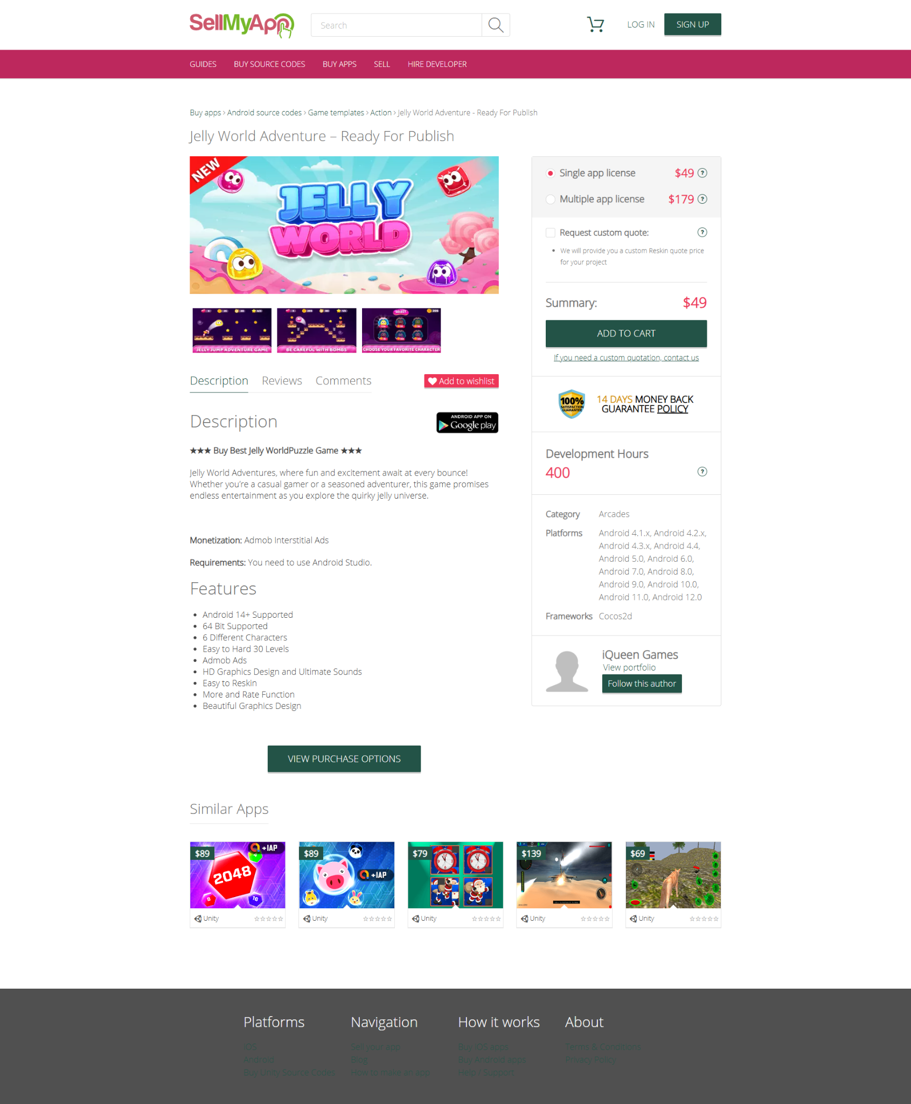

1. https://www.sellmyapp.com/downloads/merge-plane-top-free-game/

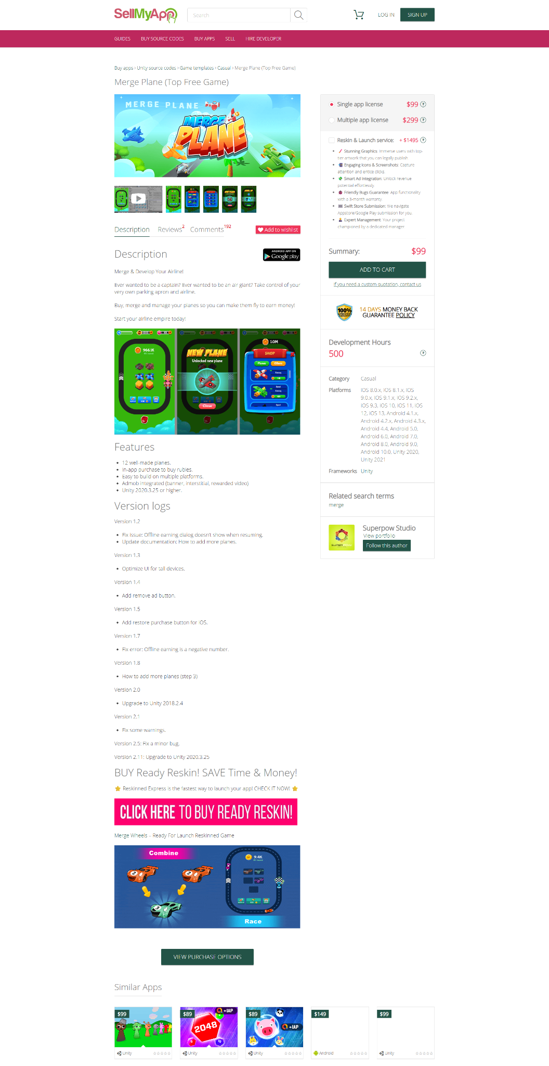

1. <https://www.sellmyapp.com/downloads/airport-plane-parking-simulator/>

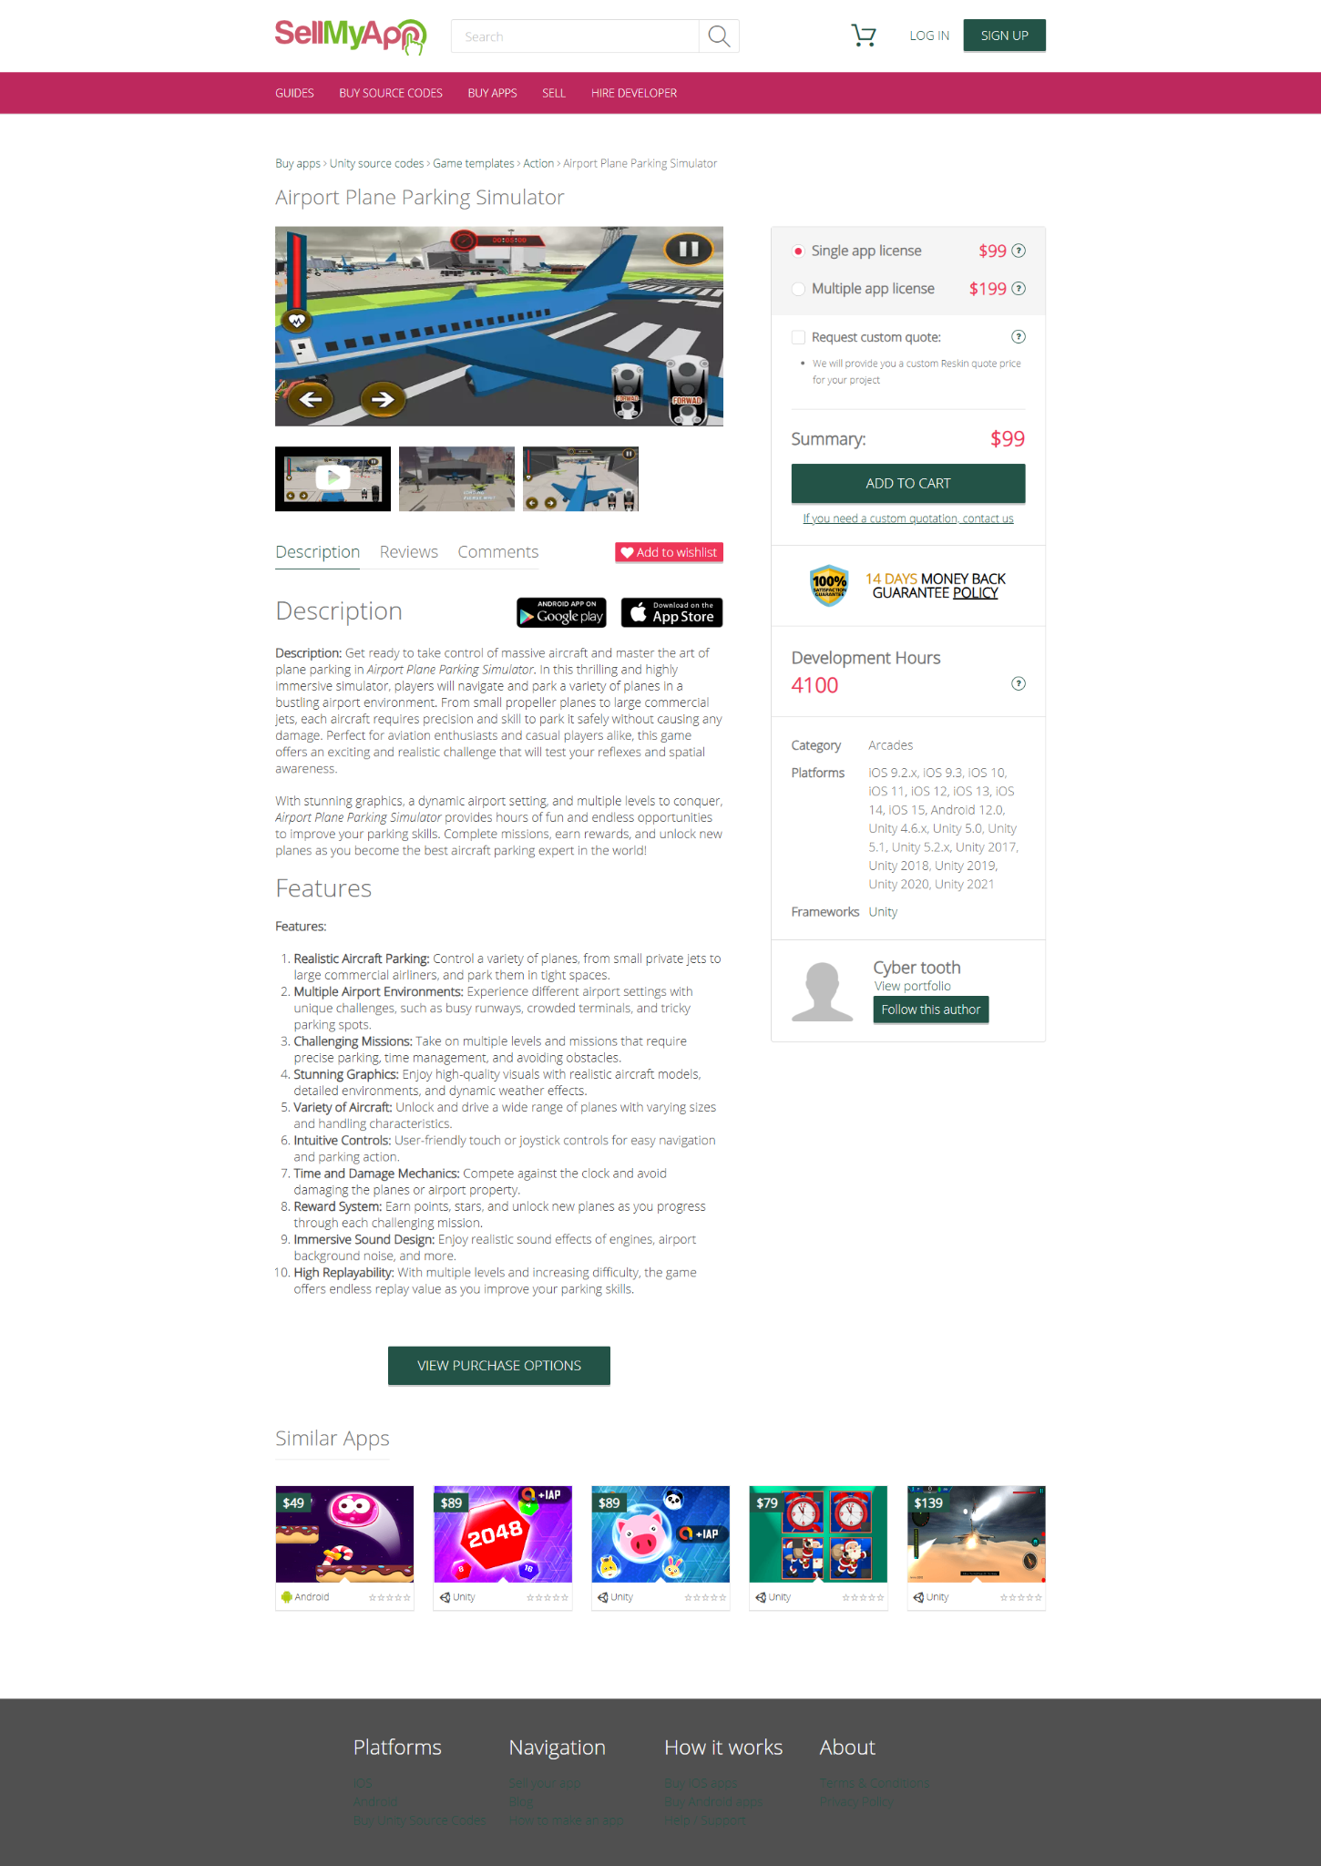

1. https://www.sellmyapp.com/downloads/rise-up-top-free-game/

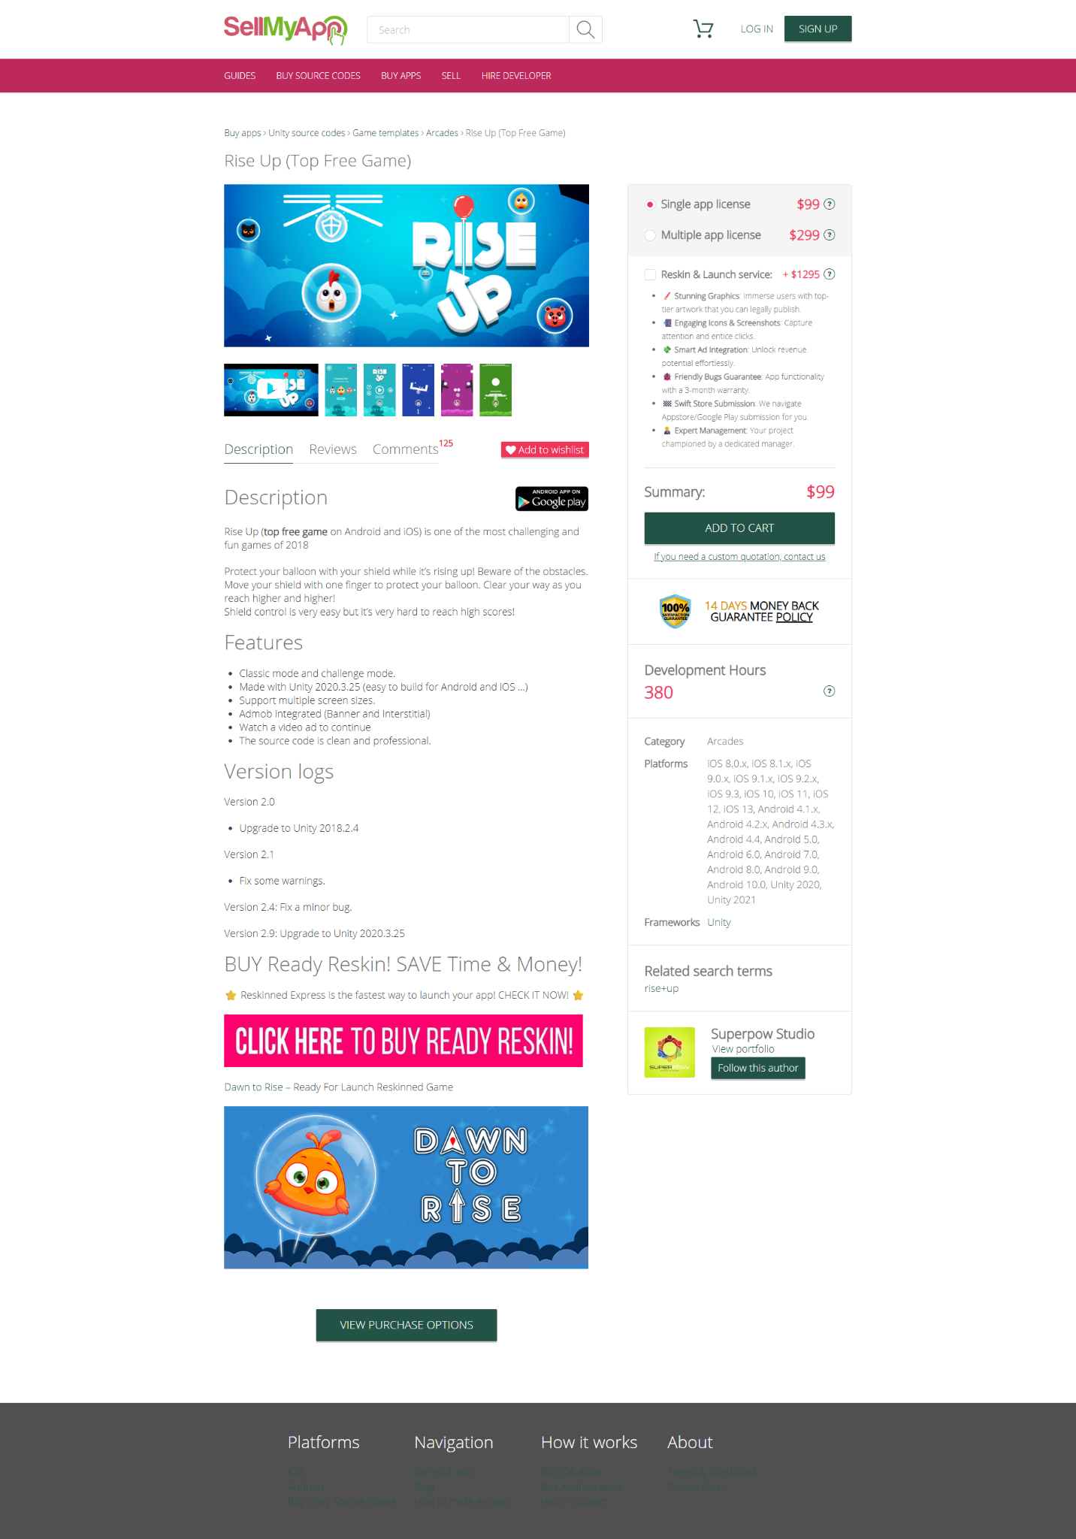

1. <https://www.sellmyapp.com/downloads/ai-games-super-bundle-offer-10-premium-games-worth-550-usd-70-off/>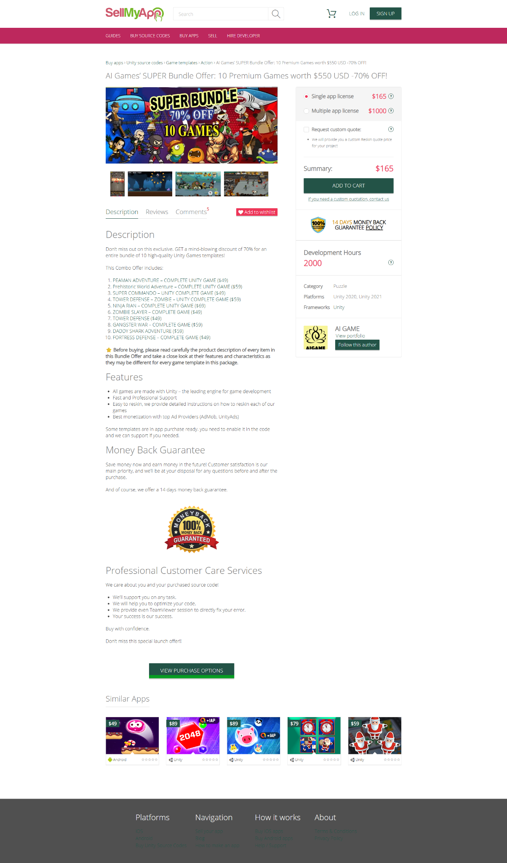
2. https://www.sellmyapp.com/downloads/shooter-craft-online-offline-complete-game-source-code/  
   